Bahria University,

Karachi Campus



LAB EXPERIMENT NO.

**_9_**

LIST OF TASKS

|  |  |
| --- | --- |
| **TASK NO** | **OBJECTIVE** |
| 1 | What is the Internet address of the gaia.cs.umass.edu (also known as www- net.cs.umass.edu)? |
| 2 | What is the Internet address of your computer? |
| 3 | Fill the below tables. |
| 4 | Access your university website and list IP address of your computer, DNS address and default gateway. |
|  |  |

Submitted On: **__13/12/2023_______**

TASKS:

1. What is the Internet address of the gaia.cs.umass.edu (also known as www- net.cs.umass.edu)?

**ANS:** [128.119.245.12]

1. What is the Internet address of your computer? **ANS:** 192.168.100.48 (Preferred)
2. 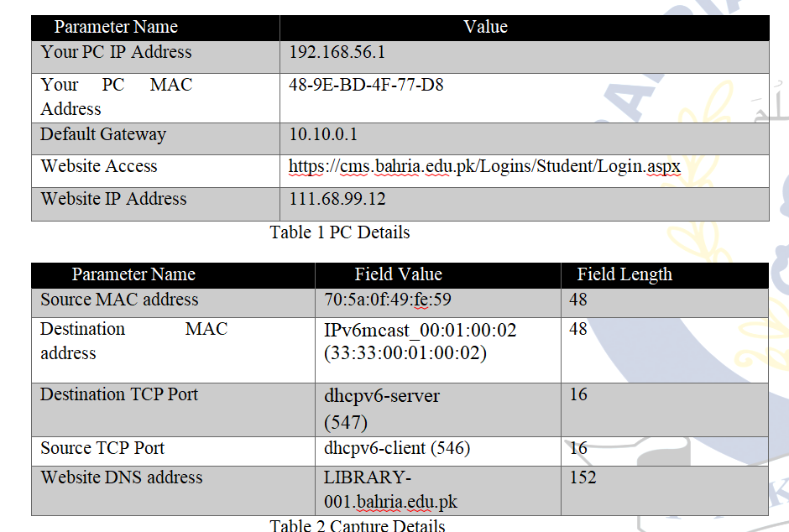Fill the below tables.
3. Access your university website and list IP address of your computer, DNS address and default gateway.

**Uni site access:**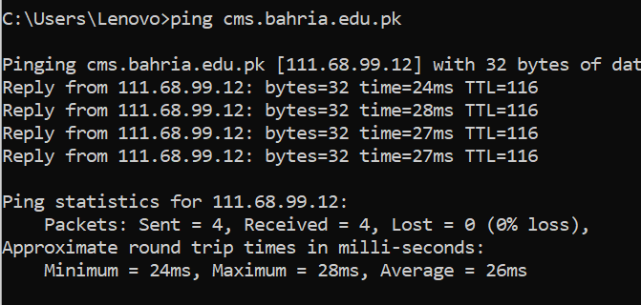

**IP of computer:** 192.168.56.1

**DNS ADDRESS:** 192.168.100.1

**DEFAULT GATEWAY:** 192.168.100.1